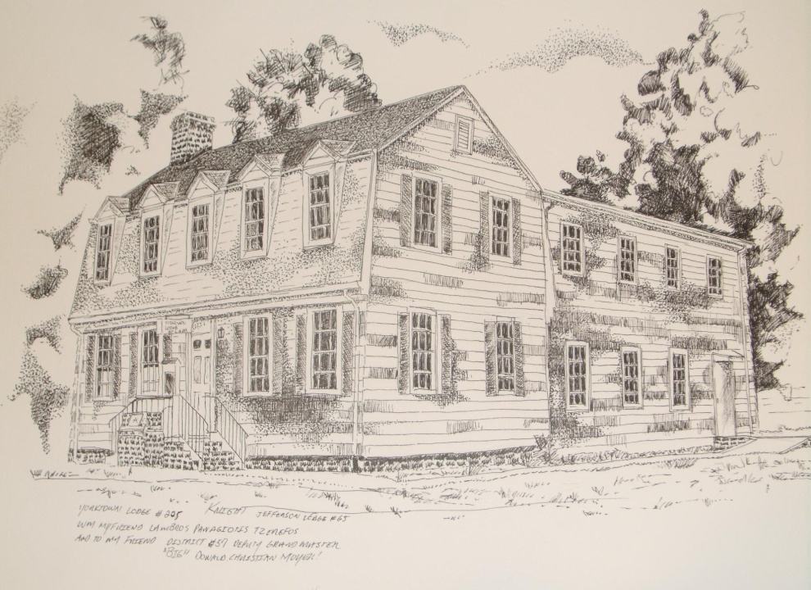

January 6, 2013
Sketch of Yorktown Lodge no 205 AF&AM
by: Glenn Knight, Jefferson Lodge no 65

Yorktown Lodge no205
P.O. Box 205
Yorktown VA 23690

